BASIC EC2 WEB SERVER

main.tf file

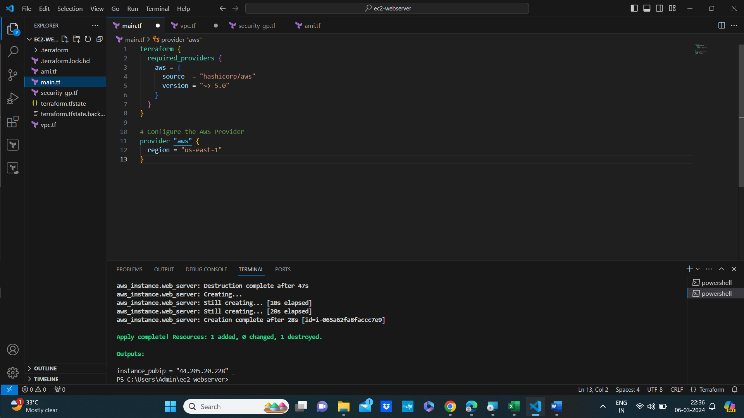

DEFINE A VPC

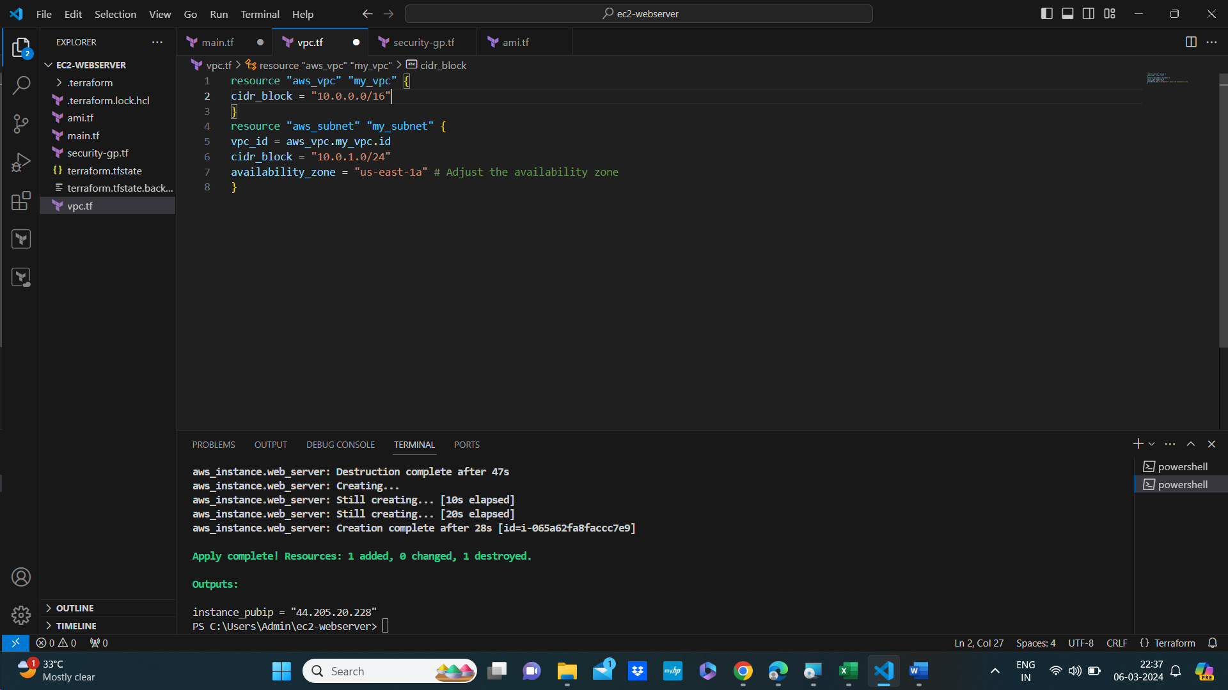

Define a security group that allows web traffic (HTTP and HTTPS):

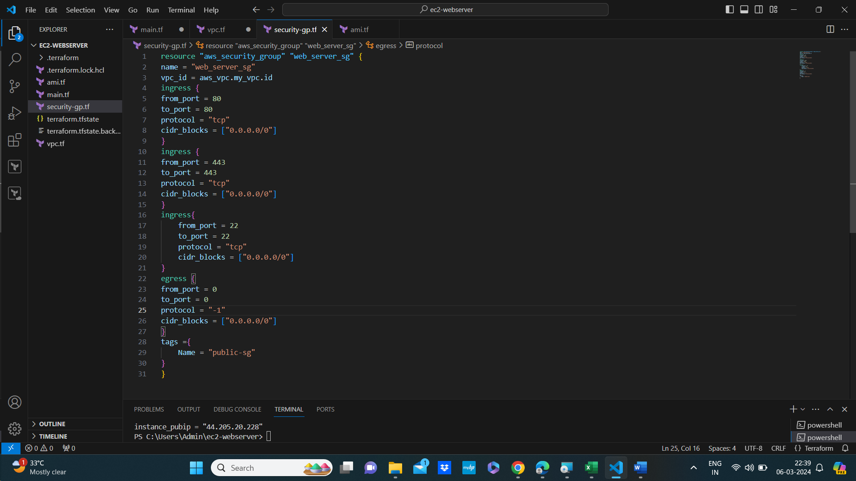

Go to the AWS EC2 console and find a suitable Linux AMI (e.g., Amazon Linux 2 or Ubuntu). Note down its AMI ID.

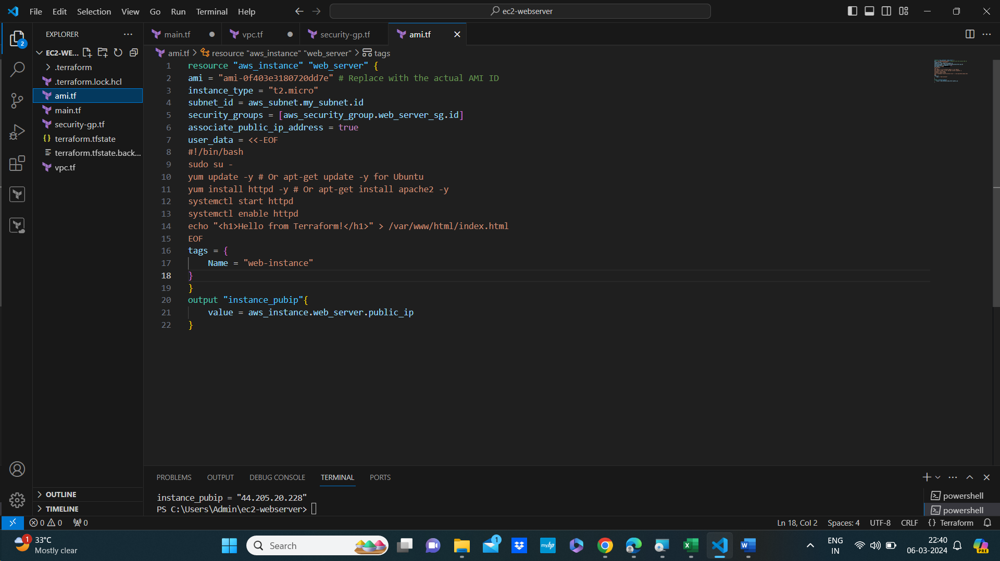

Once Terraform finishes, it will output the public IP address of your EC2 instance. Copy this IP address.

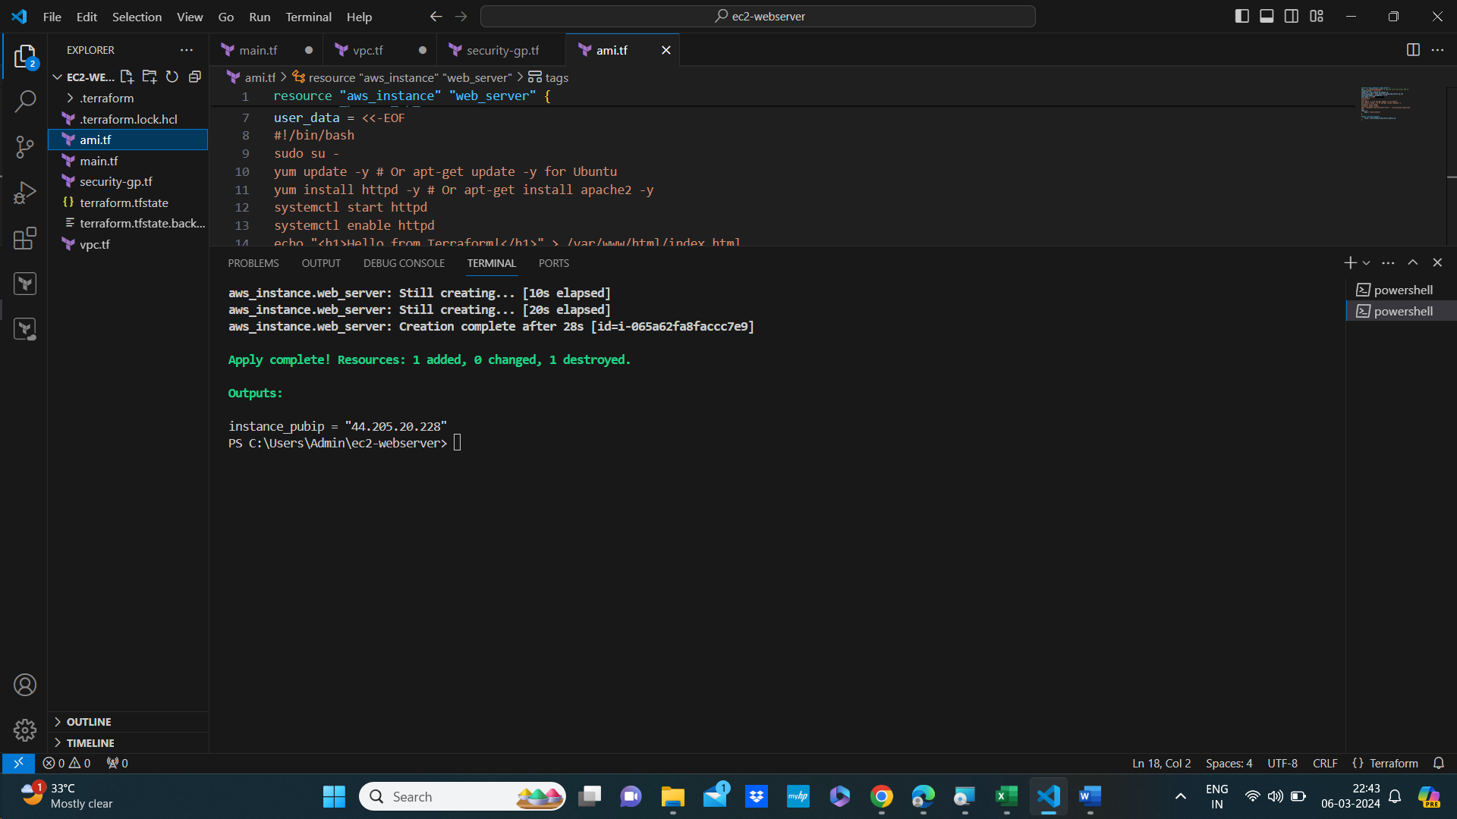

Open a web browser and paste the public IP into the address bar. You should see the “Hello from

Terraform!” message.

Web server

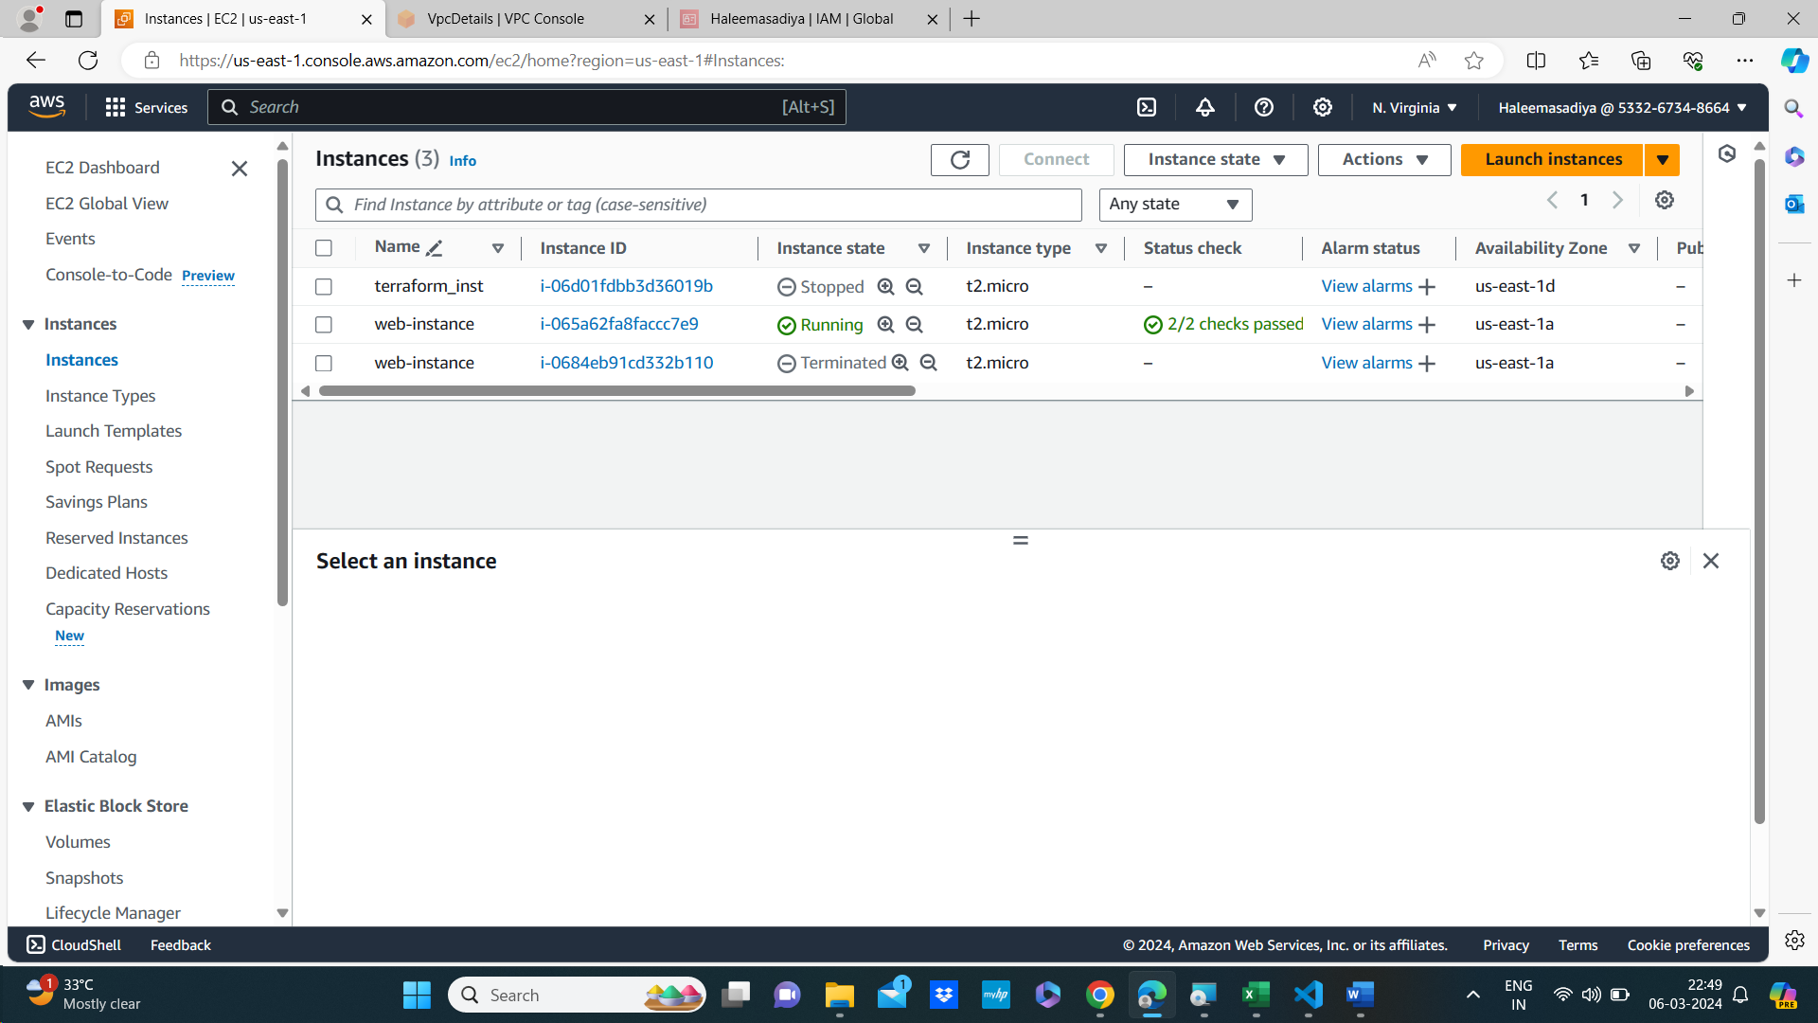

Security groups

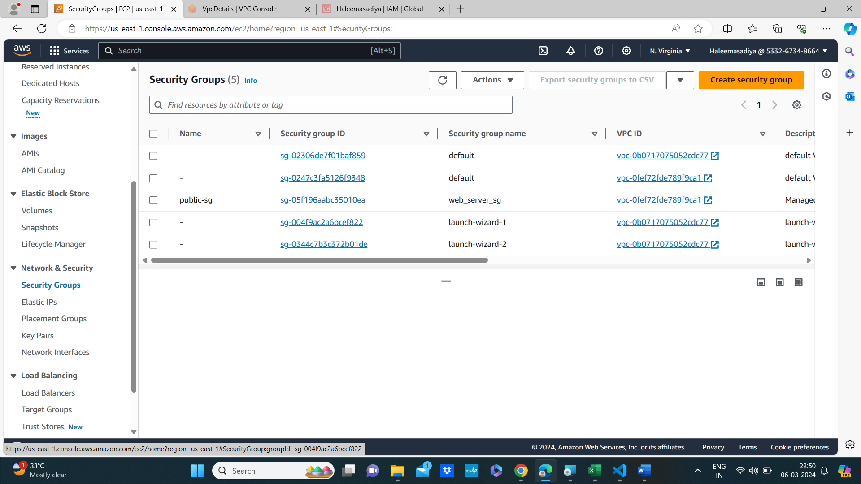

VPC

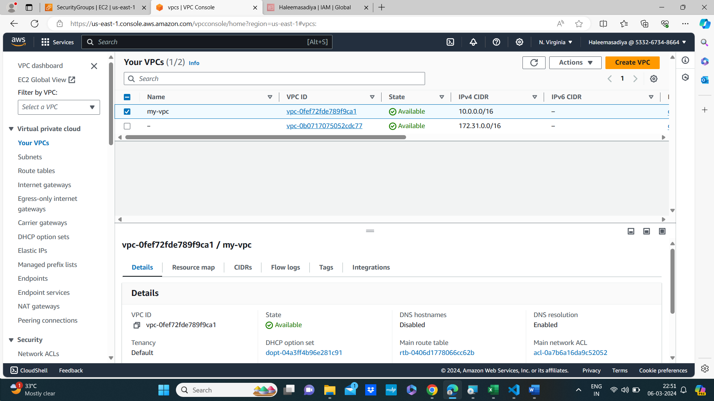

Internet gateway

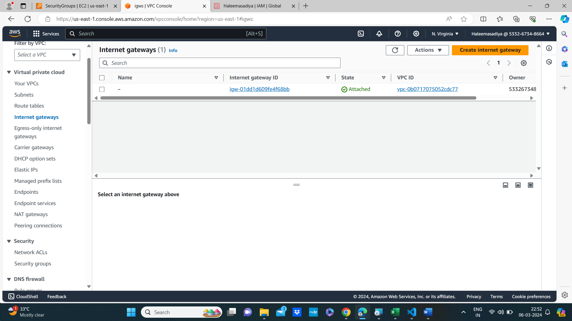

Subnets

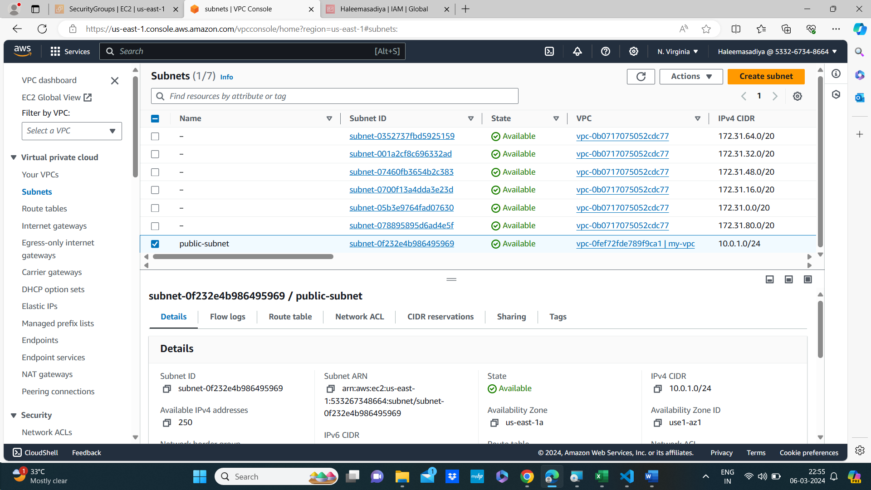

Route table

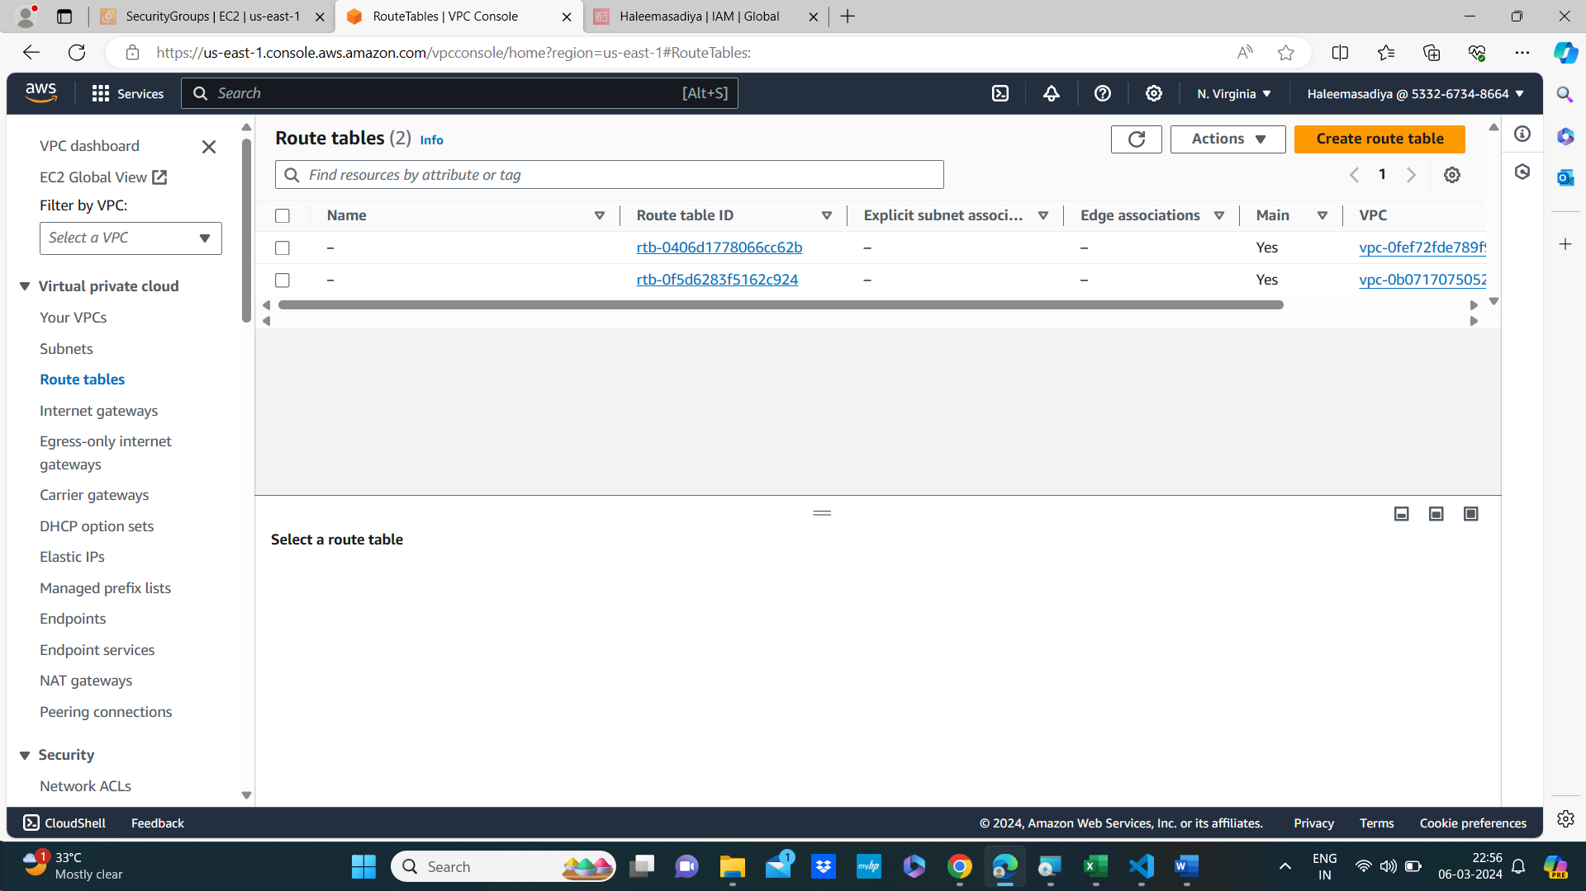

Destroyed all the resource

